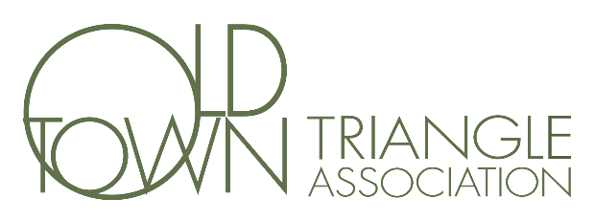
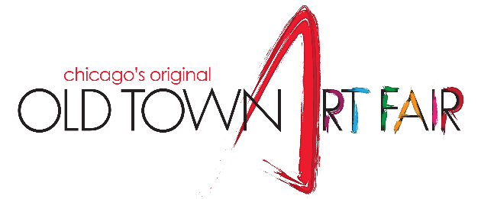
Dear Friends,
Old Town Art Fair weekend is truly a favorite weekend of the summer. This past year has taught us to hold on to what is good and celebrate whenever we can. Everyone associated with the Old Town Art Fair is thrilled to be planning the Fair and hopes this will be the best year ever.
Monies raised from the Fair support a variety of neighborhood programs. As an example, your donations benefit neighborhood organizations like the Menomonee Club and Deborah’s Place, along with art and theater programs, and local schools, including Lincoln Park High School and LaSalle Language Academy.
I am writing to ask you to consider becoming a Friend of the Fair by making a direct contribution. Donations of any amount are greatly appreciated, and they help us long before the Fair opens its gates. Donations received by April 30th will be recognized. The Old Town Triangle Association is a 501(c)(3) nonprofit and recognized for matching gifts if you have a program at your office.
To everyone who donated to the 2020 Art Fair, thank you from the bottom of our hearts. The city of Chicago has not yet decided on the fate of the Art Fair this year. Planning for a positive outcome requires that some payments must be made before a decision is reached. Please consider making your Friend of the Fair donation non-refundable this year, in the event the Fair is not allowed. This will allow the Association to recoup Fair expenses paid to date.
Of course, if approval is granted, the Old Town Art Fair is a GO!
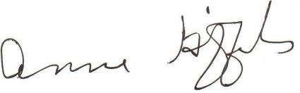
Thank you for your contribution. We look forward to seeing you on June 12th & 13th at the Fair!

Anne Giffels, Art Fair Chair
~~~~~~~~~~~~~~~~~~~~~~~~~~~~~~~~~~~~~~~~~~~~~~~~~~~~~~~~~~~~~~~~~~~~~~~~~~~~~~~~~~~~~~~~~~~~~~~~~~~~~~~~~~~~
Name as it should appear in program: _________________________________________________________________________
Name: _________________________________________________________________________________________________
Address: _________________________________________________________________________________________________
Email: _________________________________________________________________________________________________
Please note: The Old Town Triangle, the parent of the Old Town Art Fair, is a recognized 501(c)(3) non-profit organization. Your donation is tax deductible to the amount allowed by law, as there are no goods or services received in return for your donation. You are welcome to drop off or mail your donation to the Old Town Triangle at the address below.

‘

Please check here to list your contribution anonymously.

‘

Supporter ($25+)

‘

Promoter

($200+)

‘

Visionary ($1000+)

‘

Friend ($100+)

‘

Advocator
($300+)

‘

Community Builder
($1500+)

‘

Partner

($150+)

‘

Presenting
($500+)

‘

Other: $

_______

‘

In Memoriam:

