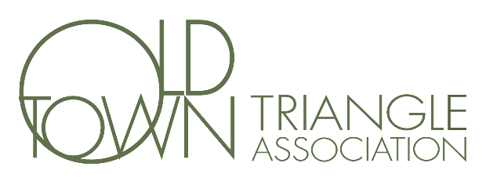
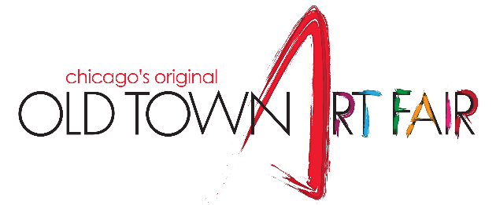
Dear Friends,
After an historic, glorious Art Fair in 2021, we are deep into planning the 2022 Fair. We can’t wait to welcome everyone to our beautiful neighborhood the second weekend in June.
The last couple of years have been especially difficult for neighborhood organizations like the Menomonee Club and Deborah’s Place, along with art and theater programs, and local schools. We are so proud and honored that proceeds from the Art Fair allow the Old Town Triangle Association the opportunity to support these very important organizations.
I am writing to ask you to consider becoming a Friend of the Fair by making a direct contribution. Donations of any amount are greatly appreciated, and they help us long before the Fair opens its gates. Donations received by April 30th will be recognized. The Old Town Triangle Association is a 501(c)(3) nonprofit and recognized for matching gifts if you have a program at your office.
To everyone who donated to the 2021 Art Fair, thank you for taking the chance with us. We genuinely didn’t know if we would be able to have the Fair, and we were overwhelmed with joy when Mayor Lightfoot announced the Old Town Art Fair was back. We expect to be able to have the 2022 Art Fair, and your donations help us bring the best Art Fair in the country to the best neighborhood in Chicago.
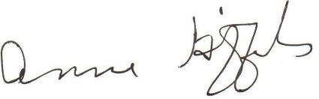
Thank you for your contribution. We look forward to seeing you on June 11th & 12th at the Fair!

Anne Giffels, Art Fair Chair
~~~~~~~~~~~~~~~~~~~~~~~~~~~~~~~~~~~~~~~~~~~~~~~~~~~~~~~~~~~~~~~~~~~~~~~~~~~~~~~~~~~~~~~~~~~~~~~~~~~~~~~~~~~~
Name as it should appear in program: _________________________________________________________________________
Name: _________________________________________________________________________________________________
Address: _________________________________________________________________________________________________
Email: _________________________________________________________________________________________________
Please note: The Old Town Triangle, the parent of the Old Town Art Fair, is a recognized 501(c)(3) non-profit organization. Your donation is tax deductible to the amount allowed by law, as there are no goods or services received in return for your donation. You are welcome to drop off or mail your donation to the Old Town Triangle at the address below.

‘

Please check here to list your contribution anonymously.

‘

Supporter ($25+)

‘

Promoter

($200+)

‘

Visionary ($1000+)

‘

Friend ($100+)

‘

Advocator
($300+)

‘

Community Builder
($1500+)

‘

Partner

($150+)

‘

Presenting
($500+)

‘

Other: $

_______

‘

In Memoriam:

Amount - Recognition

